INSTITUTE OF ASSET MANAGEMENT
CANADA CHAPTER

2020 ANNUAL GENERAL ASSEMBLY
MINUTES

1. Call to Order
The 3rd Annual General Meeting of the Canada Chapter of the IAM was called to order by Boudewijn Neijens, Chapter Chair, on Thursday, April 30, 2020 at 1:00pm, Pacific Time, via GoToMeeting and by teleconference.

2. Calling of the Roll
Attendance was confirmed to be 21 Members present online, 3 Members by proxy, for a total of 24 voting members. With a total of 123 voting members, a quorum of 20% of the voting membership was deemed to have been achieved.

3. Approval of Invited Guests
There were no guests formally attending the AGM.

4. Approval of the Agenda
The agenda was approved unanimously.

5. Adoption of the Minutes of the Previous General Meeting
The minutes of the 2019 AGM held on June 10, 2019 were presented to the members. There being no errors or omissions identified, it was
RESOLVED THAT the minutes be adopted as distributed. CARRIED

6. Business arising from the Minutes
- North America Conference
The members were informed that the 2019 NA conference made a profit. The 2020 NA Conference is to be held on November 17-19 and the conference committee is looking for sponsors.
- Report from the Branches
The branch leaders provided a brief report to the members on the number of events that had been held at each branch and the attendance at those events.
- Translations
It was noted that the IAM exams will soon be available in French, Spanish and Dutch
- Register of Professionals
The members were informed that the Register of Professionals will be open soon

7. Financial Business
- Financial Statements
The Treasurer tabled the 2019 financial statements of the Society and provided a report.
IAM UK informally notified IAM Canada that the net income from the 2019 North American IAM Conference held in Chicago was approximately $54,000 CDN. The accountant, Bradley Ouellette, CPA, CA, who prepared the 2019 financial statements identified that there are three criteria that need to be satisfied to recognize revenue. These are as follows:
- Performance obligations have been met
- Knowledge of the amount that will be received
- Nearly certain the funds will be collected.
Based on communication with IAM UK, there is uncertainty regarding the amount that will be received and that the funds will be collected. This is due to the financial challenges that IAM UK is experiencing due to the COVID-19 pandemic. As only one of the above criteria could be met the Chapter’s accountant, it was recommended that the Society not show the funds as a receivable.
After some discussion, it was
RESOLVED THAT the financial report be approved CARRIED [Refer to Annex 2 for the statements.]
- Member Dues
The Membership was informed that dues are currently being set by IAM Central and are mainly used to finance Membership services and general overhead. IAM Canada receives funds from IAM Central to cover Membership services.
- Appointment of Public Accountant
The Membership was reminded that since the Society is a non-soliciting body with gross annual revenues less than $1M, the appointment of a Public Accountant is optional. After some discussion, it was then,
RESOLVED THAT the Society be exempt from the appointment of a Public Accountant for the 2020 fiscal year CARRIED.

8. Member proposals
- Webinar Series
The Membership was informed that a series of educational webinars will be started and interested parties should notify the Chapter Chair.

9. Board Nominations and Election of Directors
- Board Nominations
The Chair reported that a call for nominations had been issued in accordance with the bylaws and the following three nominations had been received:
- Catherine Dallaire (Ottawa)
- David Albrice (Vancouver)
- James Jorgensen (Toronto)
Lengthy discussion ensured on the nominations process and a few members expressed concern that the nomination process was not sufficiently visible and suggested that any call for nominations should, in future, be issued in a separate notice and not in the same notice as the notice of the AGM.

- Election of Directors
With three of the current seven Directors standing down and four continuing for a second year of their term, it was,

RESOLVED THAT the three Directors be elected CARRIED with one abstention [Refer to Annex 3 for a list of 2020/21 Directors]

10. Other business
a) Information Portal
A Member questioned whether there is a portal for Members to view the Chapter’s bylaws and storage of other information like financial statements. In response, the Membership was informed that a Members Only portal had recently been set up on the IAM website, but this has not been populated as the Chapter does not yet have access.

11. Adjournment
The meeting was adjourned at 2:10 pm, Pacific Time, until the next General Meeting to be held at date and time to be determined.

Annex 1: Chair Comments
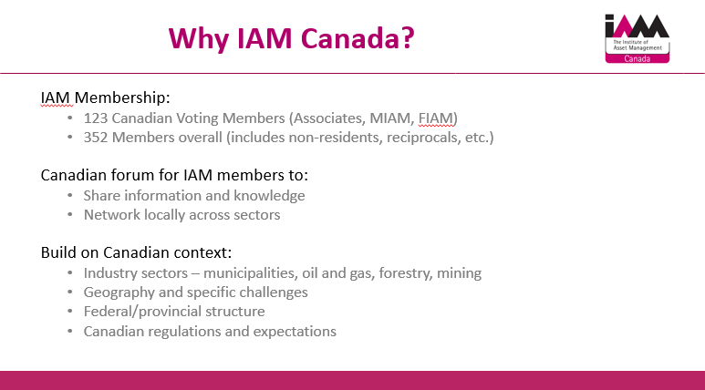
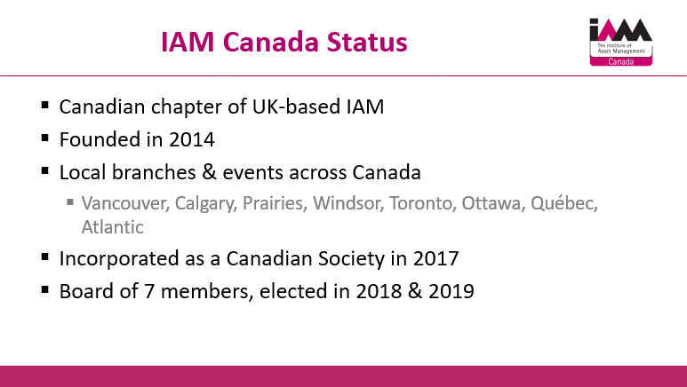
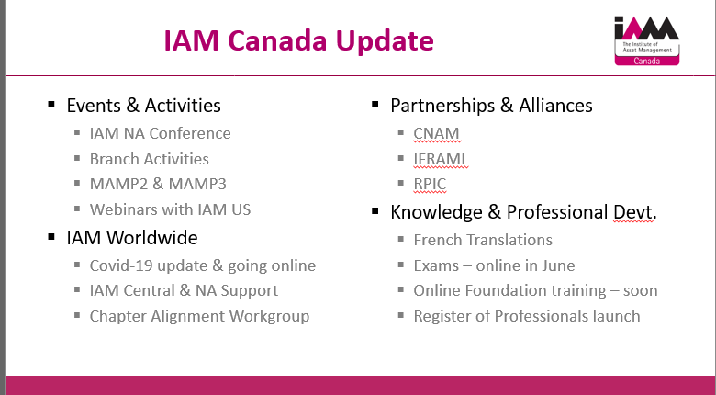
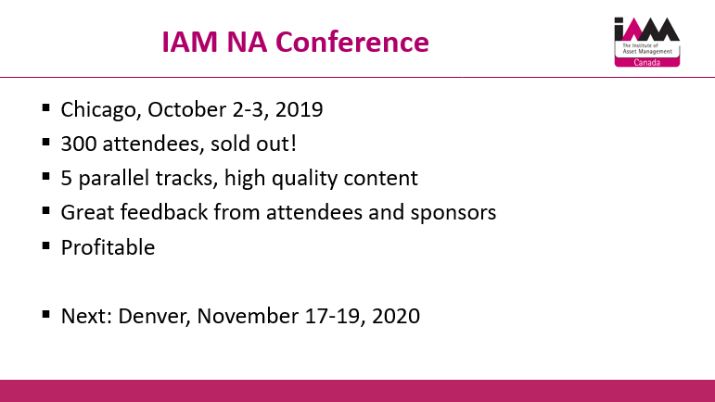
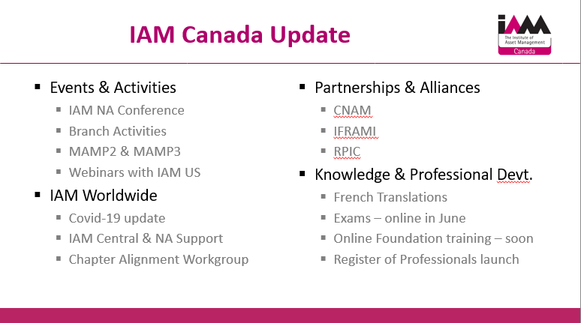
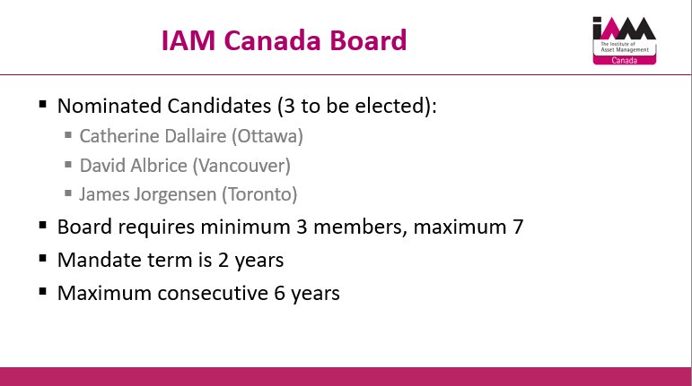

Annex 2: Financial Statements of
INSTITUTE OF ASSET MANAGEMENT CANADA

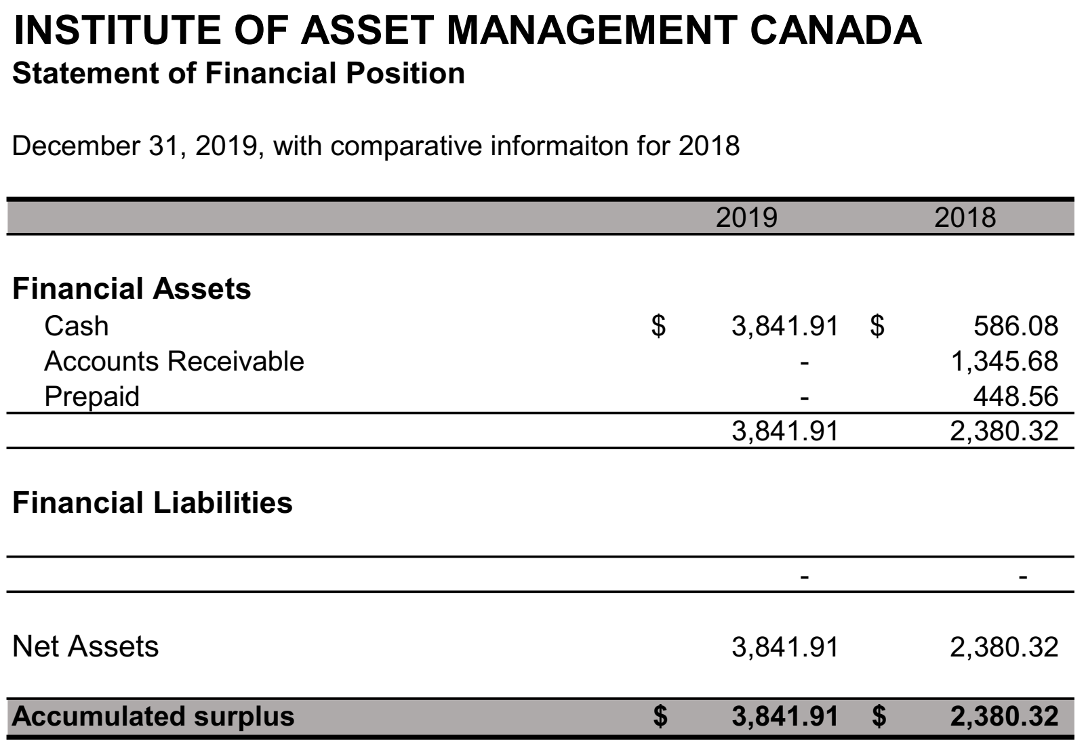

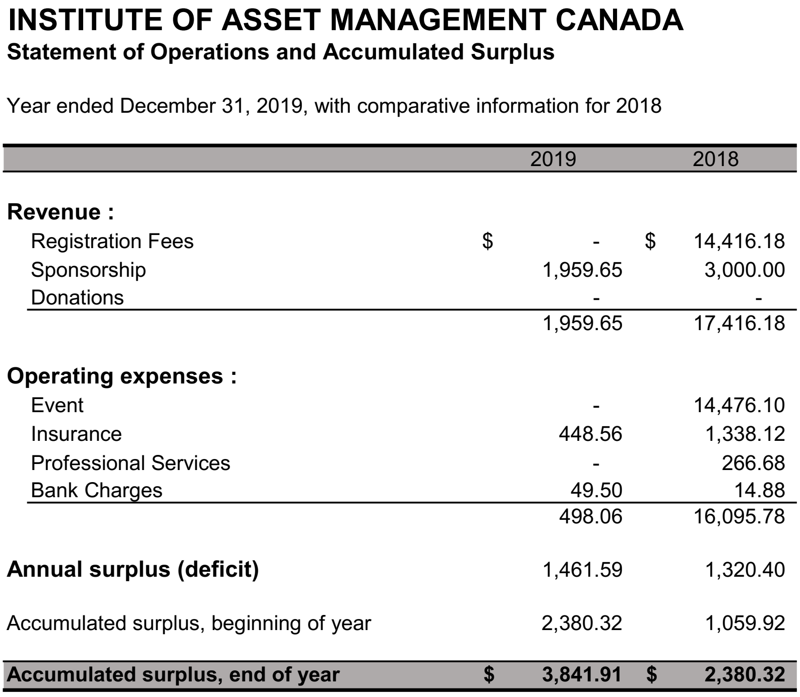

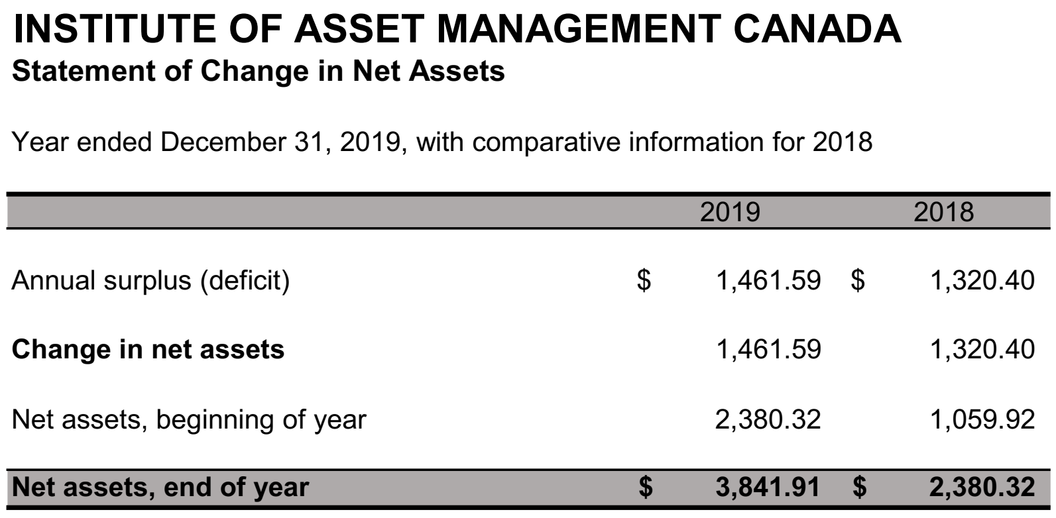

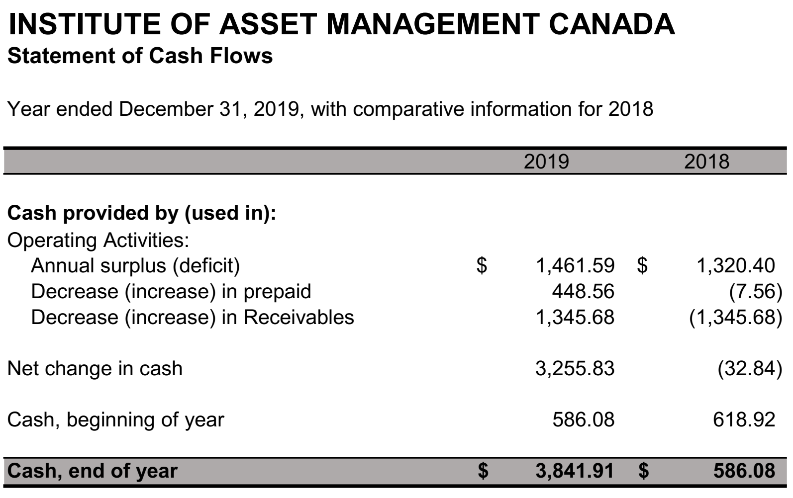

Annex 3: 2020/2021 IAM Canada Directors
Position | Name | Branch
Chair | Boudewijn Neijens | Vancouver
Secretary | David Albrice | Vancouver
Treasurer | Hans Kogel | Windsor
Director at Large | Bernard Gaudreault | Québec
Director at Large | Catherine Dallaire | Ottawa
Director at Large | James Jorgensen | Toronto
Director at Large | Bonnie Tam | Toronto

Annex 4: Members Present at the AGM
Albrice, David
Bacchus, Stephen
Cranston, Iain (by proxy)
Dallaire, Catherine
Gaudreault, Bernard
Goodfellow, Nik
Homeniuk, Ross (by proxy)
James, Owen
Jorgensen, James
Knight, Mark
Kogel, Hans
McDowall, Ann
McLenaghan, Grace
Neijens, Boudewijn
Nichols, Andrew
O’Connor, Bernadette
Reimer, Jonathan
Rivenell, John
Saidur, Rahman
Schmidt, Anelisa
Smeaton, Paul (by proxy)
Sumpton David
Tam, Bonnie
Vine, Sarah

